INFO3111 “C++ Graphics”: Make-up Midterm Exam, Tuesday, July 29th, 2025
Instructor: Michael Feeney

The exam format:
- You may use any resources you feel are necessary to complete the exam, but you are to answer the questions on your own. I will be looking for plagiarism (i.e. copying) very carefully. There is no possible way that the specific code to answer these questions, or the output to the screen, would be very similar to the look of another student’s code. Remember, this is a test and there are very clear policies about cheating on tests.
  - http://www.fanshawec.ca/admissions/registrars-office/policies/cheating-policy
  - http://www.fanshawec.ca/sites/default/files/assets/Ombuds/cheating_flowchart.pdf

- The questions are NOT of equal weight and don’t add to 100%. Bonus questions are simply added to the total amount - as if they are "regular" questions - but bear in mind that as they are "bonus", will be marked to a higher standard.
- You must set aside a three (3) hour block of continuous time with a 24 hour period (technically 12:01 AM to 11:59 PM) to do this exam. I will base this on a number of factors:
  - When you accessed the exam on FOL
  - When you submitted the file to FOL
  - The log file that is generated
  - The file meta data (if there’s anything “odd” about them)
(i.e. you do not “have 24 hours” to complete the exam – you have any 3 hours within those 24 hours)
- The exam has seven (7) questions and seven (7) pages.

- CLEARLY indicate which answer goes to which question.
  - If you feel that the questions “build on each other” (which they do) feel free to submit a single solution/project.)
  - If you feel it’s clearer to have the submissions separate, I’d suggest placing separate questions in separate projects and folders.
  - If I can’t make heads or tails of what question is what, I probably won’t even mark it.
- Do NOT do some clever “oh, you just have to comment/uncomment this block of code” submission -
I'm not going to edit your source code in any way and will run the code as submitted.
- If you feel I need to know something (key mappings, that you edited the 3D models, etc.) please indicate this with a “readme” file or some note in the root folder (not buried in the source code/project folders somewhere).

- Submit the entire solution(s) and project(s) not just the source code files.

- You are NOT permitted to use any type of AI. If I get a sense that you’ve done this, I’ll will orally/verbally interview face-to-face/zoom, asking you questions about your code, and if I get a sense you didn’t write it (aka don’t understand it/don’t know why you put that code there in that way) then I will assume you’ve cheated, just as if you’d gotten the code from somewhere else – aka, you cheated and will follow the A136: Academic Integrity policy: https://www.fanshawec.ca/sites/default/files/legacy/oldfanshawe/sites/default/files/assets/policies/pdf/a136.pdf
- Please, for all that is good and sane in the world, delete any files you don’t need as well as any temporary files Visual Studio creates (“.vs”, the debug and release folders, etc.). You won’t lose marks for submitting these, but it’s very annoying and it’s something you should know how to do.

- If the solution does not build (and run), I will not mark it (so you will receive zero on questions that can't be built and/or won't run). When I say "run", I'm not speaking about some, random, unforeseen bug, but rather something that you should have obviously dealt with, like memory exceptions, etc.

- While I might use the Debug build while marking, your submissions must build and run in Release build.
- Unless otherwise indicated, all these solutions assume that you are creating/using a C++ project using Visual Studio 2022 using the OpenGL 4.x API (with GLFW, glad, and GLM), and build in 64-bit Release using the default setting in Visual Studio (C++ 14).

- You are NOT permitted to use any type of AI (i.e. something local as you can’t use the internet).
If I get a sense that you’ve done this, I’ll will orally/verbally interview face-to-face/zoom, asking you questions about your code, and if I get a sense you didn’t write it (aka don’t understand it/don’t know why you put that code there in that way) then I will assume you’ve cheated, just as if you’d gotten the code from somewhere else – aka, you cheated and will follow the A136: Academic Integrity policy: https://www.fanshawec.ca/sites/default/files/legacy/oldfanshawe/sites/default/files/assets/policies/pdf/a136.pdf
- Your solution may not contain any third-party libraries (like boost), smart pointers, or the “auto” keyword.
To be clear: if you have any of these elements, you will receive a mark of zero (0) for that question.
NO exceptions: you should be aware of what’s currently used in industry (99% C++98/2003), and what just happens to be in the newer standards.
Some notes about the models:
- Most of the models are same as the ones in the Dungeon_models.7z file
(the same models that you are using for project #1 and the files that are in the github folder).
- You will also need (from FOL, under “Content”, then “Mid-term”):
(Note: These are not posted on github)
  - The Additional_Mid-term_Models.7z file.
  - The INFO3111_S2025_GardenMazeMaker.7z file.

If you have not downloaded these files from FOL, DO THIS NOW and GET OFF THE NETWORK – if I see you on the internet (FOL/github/anything) and you are not uploading your exam, I will assume you are cheating – see page 1.

That also goes for help or any other webpage that I see.
Close your browser(s) and put away your phones.

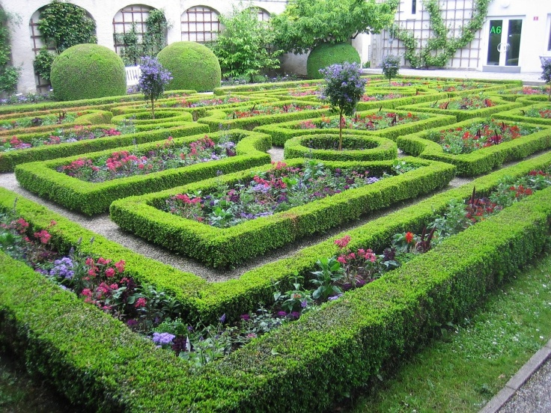

You are going to make a cozy garden labyrinth/maze, something of like this

The Questions:
- (5 marks) Generate your “garden” layout:
  - Run the INFO3111_S2025_GardenMazeMaker.exe file. This is similar to the tool you used to generate your “dungeon” for project #1.
XXXXXXXXX
X.......X
XXX.XXX.X
..X.X.X.X
X.X.X.X.X
X...X.X.X
XXXXX.X.X
X.......X
X.XXXXXXX
  - It will generate a series of “caves” that look like this
  - In this instance, the “.” characters will be floor tiles and represent a path through the garden maze, where the “X” is ground/grass/whatever (i.e. not the maze).
  - Be sure to submit the .log file that is generated!

- (200 marks) Draw the “garden path” on the “ground”.:
  - Like Project #1, your “maze” is made up of rectangular floor tiles.
  - Chose some large “Ground” mesh. You can generate this using the fractal terrain generator on meshlab, a large square or spere, or something else. The idea is that this much larger than the maze and is just something that you are putting the floor tiles (and later plants) onto. I should not be able to see the “edges” of this “ground” model.
  - Colour this “ground” model some green colour to represent grass.
  - Choose a single floor tile style and create the “.” portions of the maze, where each “.” character is one floor tile. These shoud be placed “on the ground” like they were large slabs of concrete/cement in a garden.
  - Make these tiles grey “cement”/”rock” coloured.
  - I’m looking to see that these are placed on the ground in the arrangement. Like they shouldn’t be oddly placed, floating about the “ground”, overlapping, or something like that.
  - Set the overall light to look like “daylight”. Place the camera so I can see the entire maze.
  - Also, make the “sky” a light blue colour. You can do this by placing everything iside a large model (likely a sphere) and making it blue, or you can change the screen clear colour.

- (100 marks) Place some trees in and around your maze.

- Using the “Tree Base” and “Tree Canopy” models, place five (5) different “types” of trees in the “ground”/”grass” part of the maze:
(i.e. not on the tiles – trees and plants can’t grow on rock/cement, right?)
  - There are two (2) types of “bases” (trunks) and four (4) “canopy” (leaves) models; you combine these in unique ways to get different “types” of tree.
  - There should be one (1) large tree in the “centre” of the maze.
Use your artistic judgement about this.
  - Place two (2) more trees near the “entrances” of the maze.
  - Place the remaning two (2) trees outiside the maze on the sizes that don’t have “entrances”. These should be some ways away from the maze, about the same distance as the width of the maze – they aren’t “right beside” it.

  - Make these “tree” coloured: trunk should be brown or white (like a birch tree) and the leaves (“canopy”) should be different colour green than the ground.

- (100 marks) Place grass all over the place.

- There are fourteen (14) different “grass” models. Randomly place fifty (50) of these all over the ground. About half of these should be “inside” the maze, while the others can be around the outside the maze.
  - I’m looking for variety here, so place different types of models at different orientations (rotations around the vertical axis) and possibly slight variations in scale.
If the “Y” axis is up (it is in the sample code), just pick a random rotation around the Y to give some variation, otherwise you’ll really notice that all the grace is “facing the same way”
  - No grass should be on any of the “floor” tiles (grass can’t grow there)
  - I don’t really care how you do this, but here’s some suggestions:
    - Just manually place them.
    - Pick a random location and see if it’s on a tile or not. If it is, pick a new location. Keep a counter of “successfully placed” grass until you’ve reached fifty (50):
      - If you are using the original text/log file, you can use the same process to place grass – only place it where there’s an “X” or it’s outside the maze.
      - You can also scan through your list of “meshes to draw” and if the any of the floor tiles is “too near” or overlaps a floor tile, then it’s a bad location

  - Make these a different green colour than the ground and tree leaves.

- (100 marks) Place some other plants:
  - Place a dozen (12) plants around the outside of the maze. These can be any of these: Bramble, Bush, Fern, Plant, Plant_Spikey, Plants, TreeDead, or TreeStump.
  - Like question 4, I’m looking for variety, so if you are using duplicates (which you likely will), then adjust the vertical (y-axis) orientation.
  - Give them some appropriate colour that’s different from the ground, grass, and trees.

- (300 marks) Place some “fireflies” around sunset:
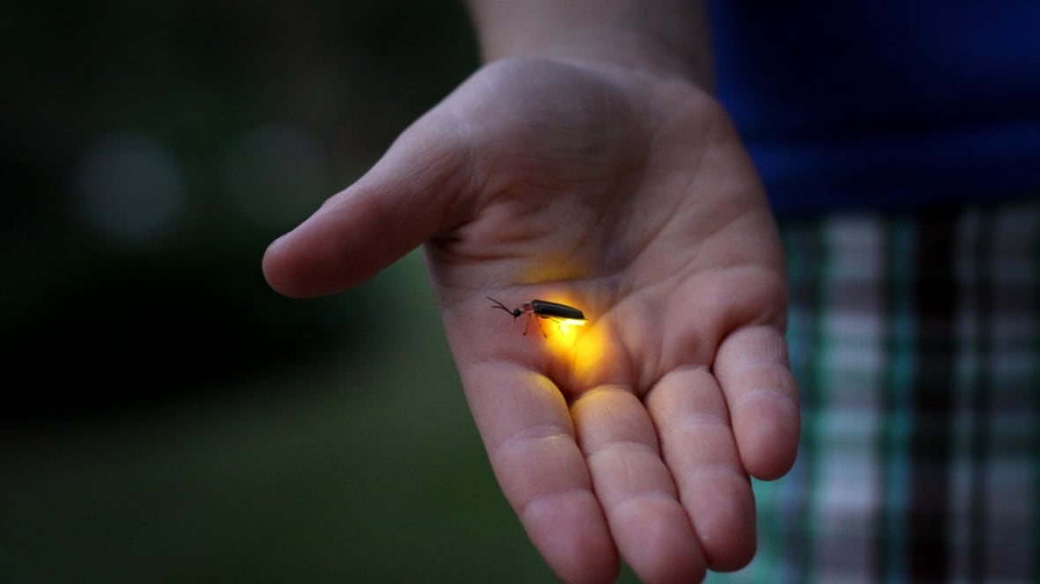
  - Adjust your lighting so it’s just after sunset/dusk – so it’s dark, but not quite nigh-time, sort of early evening.
  - If you haven’t seen fireflies, they are little bugs that have glowing abdomens. They are around London this time of year, usually right after sunset and usually fly around head-height over grass fields. They fly around really slowly, turning off and on the light, so they look like little flashing yellow stars near the ground.
  - Mimic this by placing ten (10) “firefly” lights:
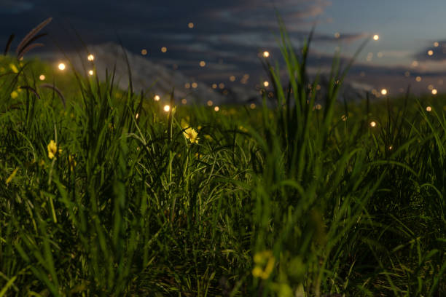
    - Use some very small model as the firefly body. Make this really, really small so you can’t really see what it is, but you can see that it’s there – it can even be the sphere or cow or bunny or something, but make it so small you can’t tell at a distance.
Assign it a very bright yellow/orange colour.
    - Place a small, very bright yellow/orange light very near this model and move the model near to one of the plants (tree, grass, whatever) so that the light “lights up” the plant.
You’ll have to use your judgement here: I need to see that it’s clearly a little, bright light, so it’ll have to be “close enough” to the grass/plant/tree models but not so close that the light is oversaturated and bright.
    - The light is “small” so isn’t lighting up anything very far away – it’s just a little firefly, right?
    - These fireflies should randomly turn on and off over a second or so.
Here’s a suggesting for how you could do this:
      - Assign each firefly a “countdown” float value, starting at 0.0f.
      - Each frame, pick a small random number for each firefly and add it this “countdown”.
      - Pick two “threshold” numbers, say 10.0f and 20.0f. If the firefly’s countdown is less than 10.0f, then its light is “on”. If it’s above 10.0f, then it’s “off”. When it’s greater than 20.0f, reset the counter to 0.0f again.
      - Because you are randomly adding little random numbers to each firefly each frame, they will turn on and off at different times.
      - If they are turning on and off too quickly, pick larger threshold numbers (the 10.0f & 20.0f) or pick smaller random numbers each frame.
  - Set the “sky” to be black by changing whatever you did in question 2 to a black colour.
(100 marks) Add some keyboard controls:
  - Assign a key/keys to switch to day and “dusk”:
    - Daytime is bright with no fireflies.
    - “Dusk” is just after sunset when the fireflies come out.
    - If you are using the same key, you have to be sure that one key-press switches it but doesn’t keep quickly switching back and forth.
    - If you are using two keys, one makes it “day” and one makes it “dusk”.
    - You have to change the sky as well: blue in the daytime and black in the night time.

That’s it.

From Stack Overflow, here's how you create a random float number:
(note that you cannot use the C++11 <random> header, since you aren't allowed to use C++11. Also, the C++11 <random> while "all that", still isn't actually bloody random... gheesh)

(https://stackoverflow.com/questions/686353/c-random-float-number-generation)

